Tag Mill Inventory for Worlds
Product Type and  Product Code | Name | Cost | Picture
Alt Art Series  TM1 | Grey Area Series - 3x Bahia Bands, 3x Petty Cash, 3x B 1001, 3x Regolith Mining Licence, 3x Sure Gamble, 3x Hedge Fund and a promotional 1x Grey Area Set Card (6 designs)  Alt Art Card Set [19 Cards] | £25 | 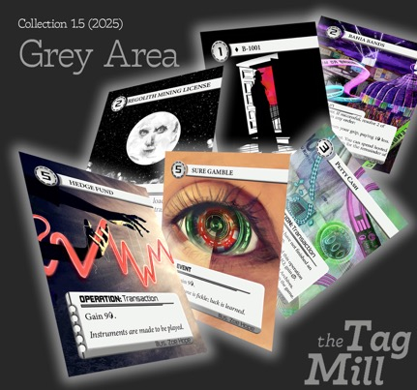
Alt Art  TM5 | Bahia Bands Playset | £5 | 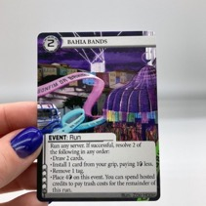
Alt Art  TM6 | B-1001 Playset | £5 | 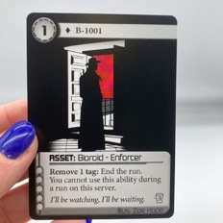
Alt Art  TM7 | Regolith Mining License Playset | £5 | 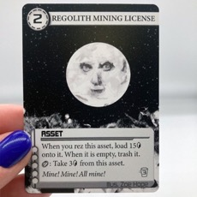
Alt Art  TM8 | Sure Gamble Playset | £5 | 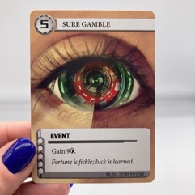
Alt Art  TM9 | Hedge Fund Playset | £5 | 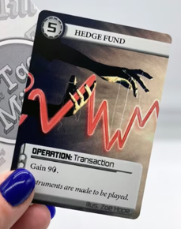
Alt Art  TM10 | Petty Cash  Playset *NEW* | £5 | 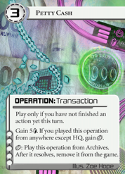
Alt Art Series  TM2 | Op Art Series - 3x Seamless Launch, 3x Spin Doctor, 3x Send a Message, 3x Anthill Excavation Contract, 3x Flyswatter, 3x Semak-samun, and a single promo 1x Op Art Set Card (6 Designs) | £25 | 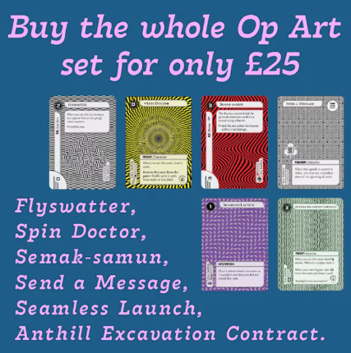
Alt Art  TM11 | Seamless Launch Op Art Playset | £5 | 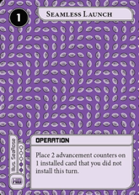
Alt Art  TM12 | Spin Dr Op Art Playset | £5 | 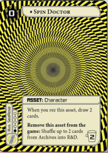
Alt Art  TM13 | Send a Message Op Art Playset | £5 | 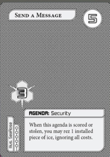
Alt Art  TM14 | Anthill Excavation Contract Playset | £5 | 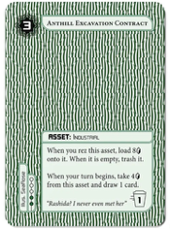
Alt Art  TM15 | Flyswatter Art Playset | £5 | 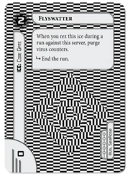
Alt Art  TM16 | Semak-samun  Op Art Playset | £5 | 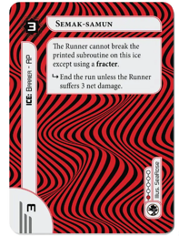
Alt Art Series  TM3 | Break In Series - 3x Begemot, 3x Buzzsaw, 3x Carmen, 3x Echelon, 3x Jailbreak, 3x Propeller, and a single promo 1x Break In Set Card (6 Designs) | £25 | 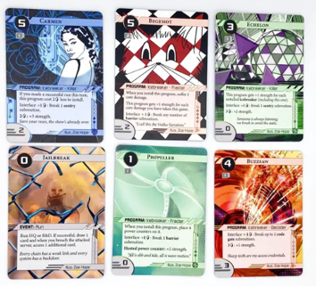
Alt Art  TM17 | Begemot Op Art Playset | £5 | 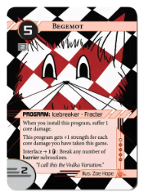
Alt Art  TM18 | Buzzsaw Playset | £5 | 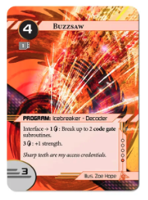
Alt Art  TM19 | Carman Op Art Playset | £5 | 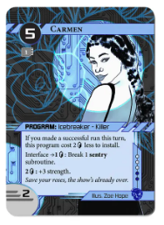
Alt Art  TM20 | Echelon Contract Playset | £5 | 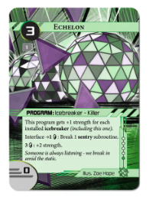
Alt Art  TM21 | Jailbreak Playset | £5 | 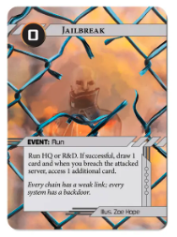
Alt Art  TM22 | Propeller Playset | £5 | 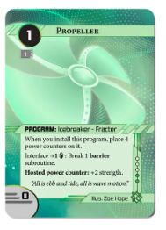
Alt Art Series  TM4 | Send It Series - 3x Cataloguer, 3x Cupellation, 3x Hannah "Wheels" Pilintra, 3x Dr Nuka, 3x Privileged Access, 3x Swift, and a single promo 1x Send It Set Card (6 Designs) | £25 | 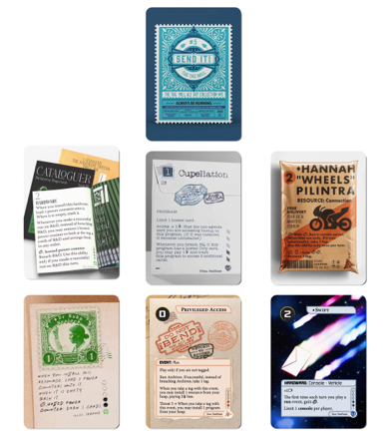
Alt Art  TM23 | Cataloguer Playset | £5 | 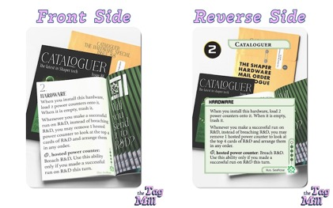
Alt Art  TM24 | Cupellation Playset | £5 | 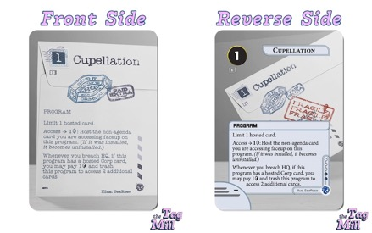
Alt Art  TM25 | Hannah "Wheels" Pilintra Playset | £5 | 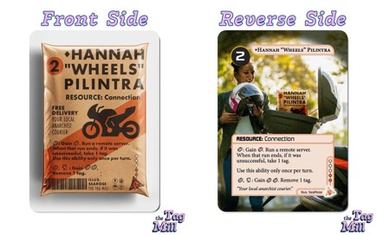
Alt Art  TM26 | Dr Nuka Playset | £5 | 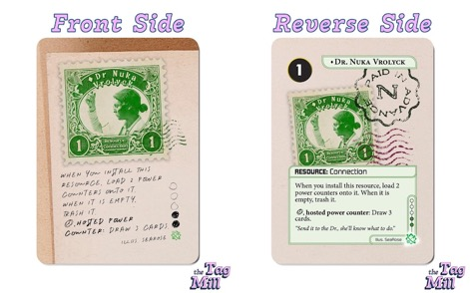
Alt Art  TM27 | Privileged Access Playset | £5 | 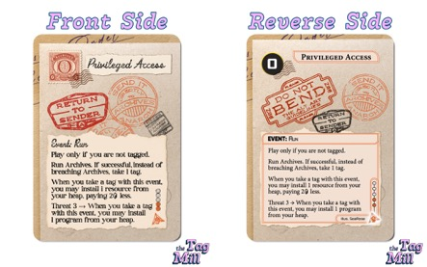
Alt Art  TM28 | Swift Playset | £5 | 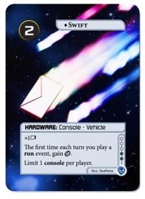
Alt Art Series  TM29-34 | Creative Commission Series –  3x Your Digital Life, 3x Muse, 3x Aniccam, 3x Strike Fund, 3x Revolver, 3x Cezve,  (6 Designs) | £25 | 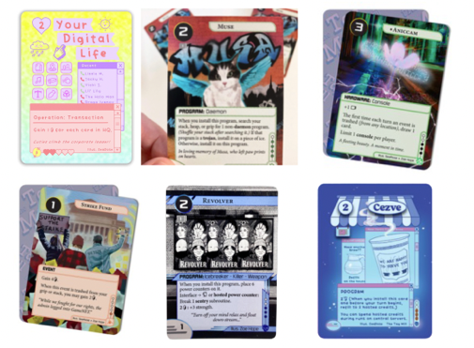
Alt Art  TM29 | Your Digital Life Playset | £5 | 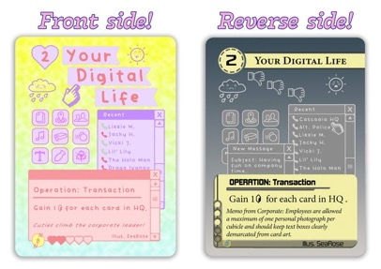
Alt Art  TM30 | Muse Playset | £5 | 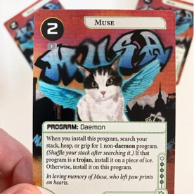
Alt Art  TM31 | Aniccam Playset | £5 | 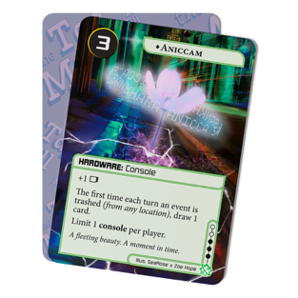
Alt Art  TM32 | Strike Fund Playset | £5 | 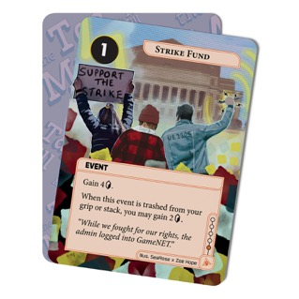
Alt Art  TM33 | Revolver Playset | £5 | 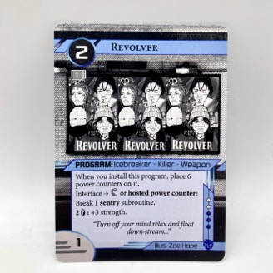
Alt Art  TM34 | Cezve Playset *NEW* | £5 | 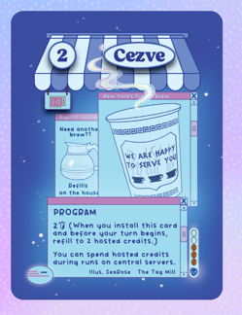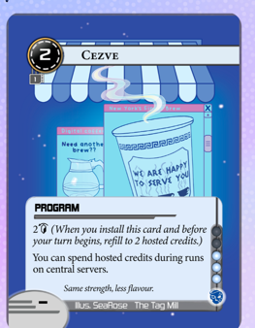
Sticker  TM35 | Zahya | £2.50 | 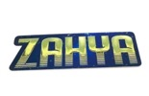
Sticker  TM36 | Loup | £2.50 | 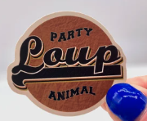
Sticker  TM37 | Tao | £2.50 | 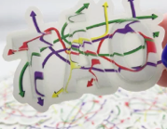
Sticker  TM38 | Restoring Humanity | £2.50 | 
Sticker  TM39 | Reality + | £2.50 | 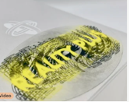
Sticker  TM40 | Precision Design | £2.50 | 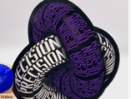
Sticker  TM41 | Built to Last | £2.50 | 
Sticker  TM42 | Arissana | £2.50 | 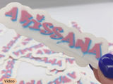
Sticker  TM43 | Slap Vandal | £2.50 | 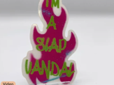
Sticker  TM44 | Oppo / Take Two Tags | £2.50 | 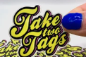
Sticker  TM45 | Jnet Vibes / Undo Click | £2.50 | 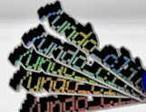
Sticker  TM46 | Run Last Click | £2.50 | 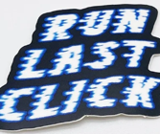
Sticker  TM47 | Trick of Light | £2.50 | 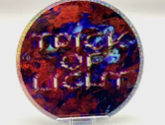
Sticker  TM48 | Credit Trio | £2.50 | 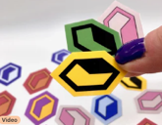
Sticker  TM49 | Trans Lives Matter | £2.50  (all profits goes to Mermaids UK charity) | 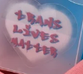
Sticker  TM50 | I Whiff Deep Dives Green | £2.50 | 
Sticker  TM51 | I Whiff Deep Dives Blue | £2.50 | 
Sticker  TM52 | I Whiff Deep Dives Red | £2.50 | 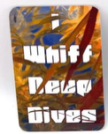
Accessory  TM53 | Pride Credits Pack | £5.00 | 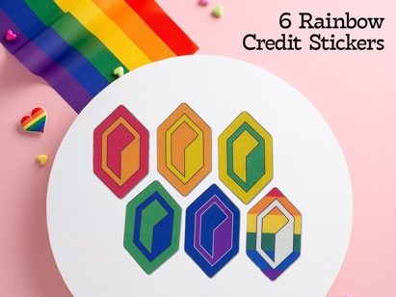
Accessory  TM54 | Queer Credits Pack | £5.00 | 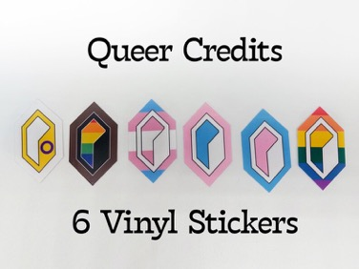
Sticker  TM55 | 100% Win Rate on JNET | £2.50 | 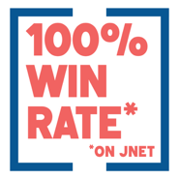
Sticker  TM56 | I Heart Netrunner | £2.50 | 
Sticker  TM57 | Sweet but Salty | £2.50 | 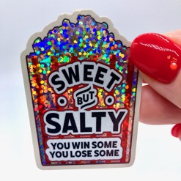
Sticker  TM58 | Snap Keep | £2.50 | 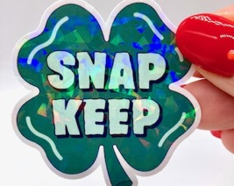
Sticker  TM59 | Jank Sauce | £2.50 | 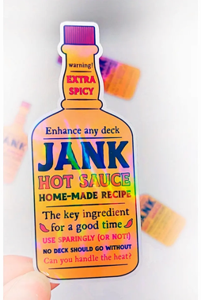
Sticker  TM60 | Warning May Contain Jank | £2.50 | 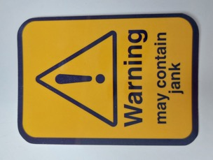
Sticker  TM61 | Sick Rips 3 colors available. Write Product Code TM61 and your preferred color(s) on your Order Form. | £2.50 |   
Sticker  TM62 | Invest In Cardboard | £2.50 | 
Other  TM63 | Click Trackers Limited colors available. Write Product Code TM63 on your Order Form and bring the item of your choice to the cashier. | £3.00 | 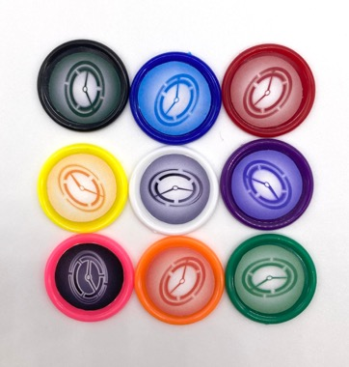  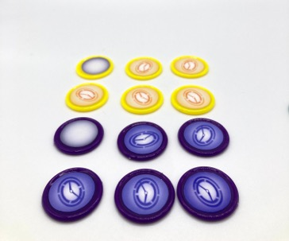
Clothes  Order online Only on thetagmerch.etsy.com | Netrunner Heavy Metal T-Shirt | £20 | 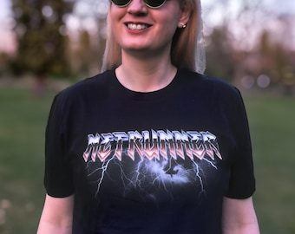
Clothes  Order online Only on thetagmerch.etsy.com | Always Be Running Embroidered Sweatshirt in Multicolour Rainbow | £48 | 
Clothes  Order online Only on thetagmerch.etsy.com | Netrunner Never Left T-Shirt | £25 | 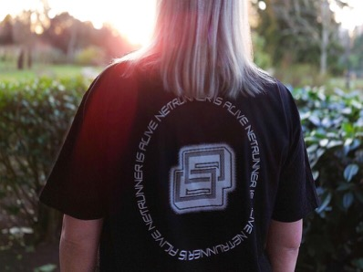
Clothes  Order online Only on thetagmerch.etsy.com | Netrunner Link T-Shirt Embroidered in Shaper Green | £25 | 
Clothes  Order online Only on thetagmerch.etsy.com | Netrunner Link T-Shirt Embroidered in Anarch Orange | £25 | 
Clothes  Order online Only on thetagmerch.etsy.com | Netrunner Link T-Shirt Embroidered in Criminal Blue. | £25 | 
Clothes  Order online Only on thetagmerch.etsy.com | Always Be Running (Cyber Edition) Netrunner  T-Shirt | £21 | 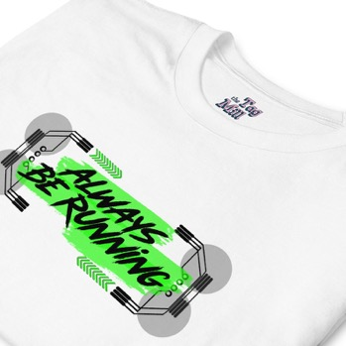
Clothes  Order online Only on thetagmerch.etsy.com | Run Last Click Netrunner  T-Shirt | £21 | 
Clothes  Order online Only on thetagmerch.etsy.com | Runner Grid Netrunner  T-Shirt | £21 | 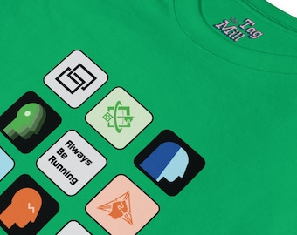
Clothes  Order online Only on thetagmerch.etsy.com | Netrunner /undoclick T-Shirt | £21 | 
Clothes  Order online Only on thetagmerch.etsy.com | Netrunner Heavy Metal Hoodie | £45 | 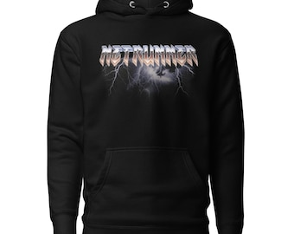
Clothes  Order online Only on thetagmerch.etsy.com | Always Be Running Embroidered Sweatshirt in Trans Pride Colours | £48 | 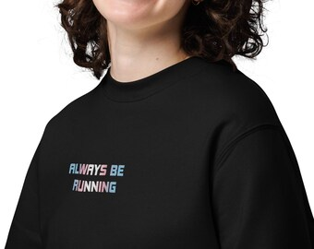
Clothes  Order online Only on thetagmerch.etsy.com | Always Be Running Embroidered Sweatshirt in Multicolour Rainbow | £48 | 
Clothes  Order online Only on thetagmerch.etsy.com | Always Be Running Embroidered T-Shirt in Rainbow Colours | £25 | 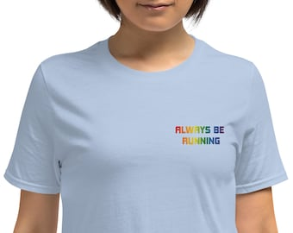
Clothes  Order online Only on thetagmerch.etsy.com | Always Be Running Embroidered T-Shirt in Trans Colours | £25 | 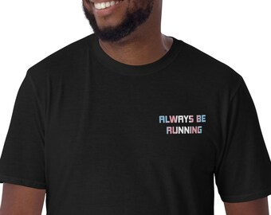
Clothes  Order online Only on thetagmerch.etsy.com | Judge!  Embroidered Hoodie  Available in gold, pink, and white thread | £45 | 
Clothes  Order online Only on thetagmerch.etsy.com | Judge! Netrunner Patch  Avaialbe in a wide range of colours | £12.50 | 

